Tips on How to Verify Business Name or URL
- Search GoldMine using the submitted email address
  - If a record is found, see if you can find the company name using your preferred search engine.
  - Please reference the section below for checking business names in GoldMine.
- Using your preferred Search Engine, take the email domain (e.g. info@atechnologies.com) and search for it with the keyword “website”
  - E.g. “atechnologies.com website”
- Search for the Phone Number
- Search for the Contact Name
  - Sometimes LinkedIn results can appear.
- Search using Insights Builder.
- Check Dynamics CRM to see if the lead has appeared before.
- Search marketing@atechnologies.com inbox to see if lead has had previous contact and been verified.

Verifying Business Name / Email in Goldmine
- View the lead form submission in Outlook
- Copy the email domain
- Login to Remote Desktop
- Open GoldMine
- Paste the email domain into the GoldMine Search Bar
  - Make sure search is set to “Email” and “Contains”
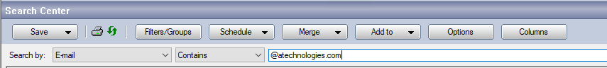
- Verify if any records exist for this domain
- If no records exist, verify the current company name, paying special attention to spelling and capitalization
- Next, search for the Company name in Goldmine
  - Make sure search is set to “Company” and “Contains”
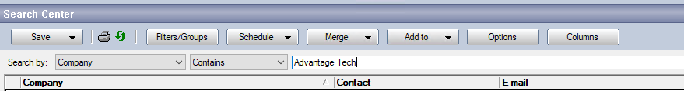
  - Depending on the company name, you may need to try searching for different variations.
    - E.g.: California Healthcare Services > California Healthcare > CA Healthcare Services or Red River Community Hospital > Red River Hospital
  - If you do see a company appear, please be sure to pay special attention to the website domain. If you are unsure if they organizations are related, view the organization domain in a search engine of your choosing and see if they match.

