SOP - Updating a WordPress Version
Process
- Login to WordPress
- On the left-hand side bar, select “Updates”
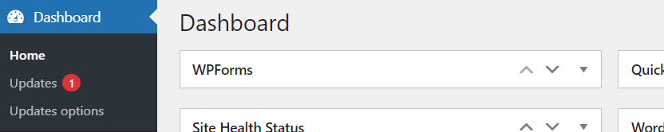
- When available, you will be prompted to update to the latest version of WordPress
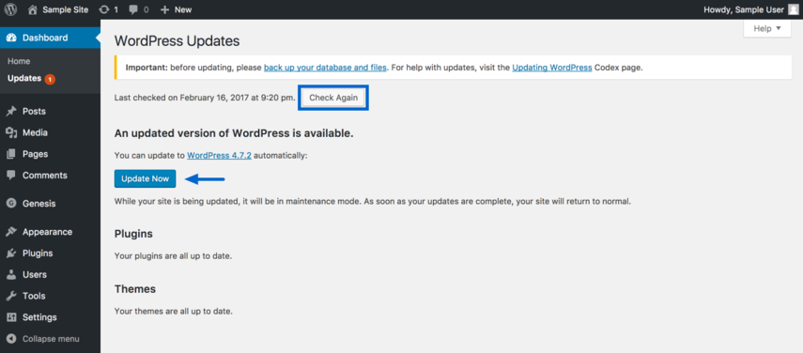
- Verify that this WordPress version will not create any issues with our site. This can be done by researching the version in correlation with our themes and major plugins.
- Once verified, hit “Update Now”
- Verify the WordPress version has updated correctly:
