SOP - Updating a WordPress Theme
Process
- Login to WordPress
- On the left-hand side bar, select “Updates”
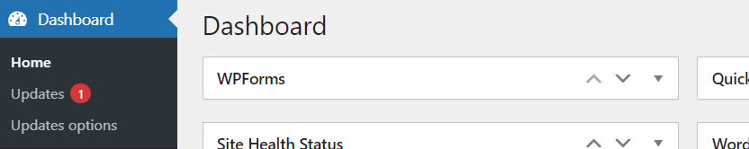
- From here, scroll down to “Theme” to locate any plugins requiring an update.
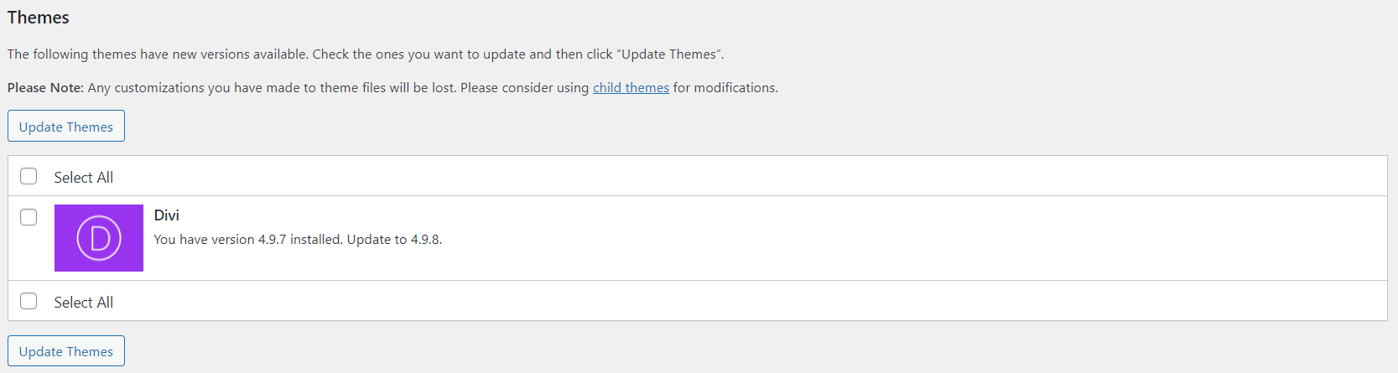
- Check “Select All” and then “Update Themes”
- Finally, verify all themes have updated correctly
