SOP - Updating a WordPress Plugin
Process
- Login to WordPress
- On the left-hand side bar, select “Updates”
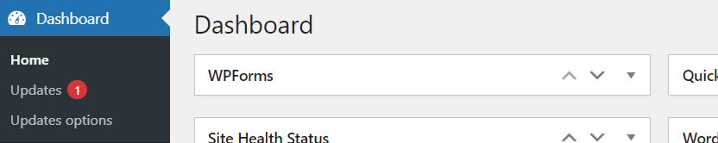
- From here, scroll down to “Plugins” to locate any plugins requiring an update.
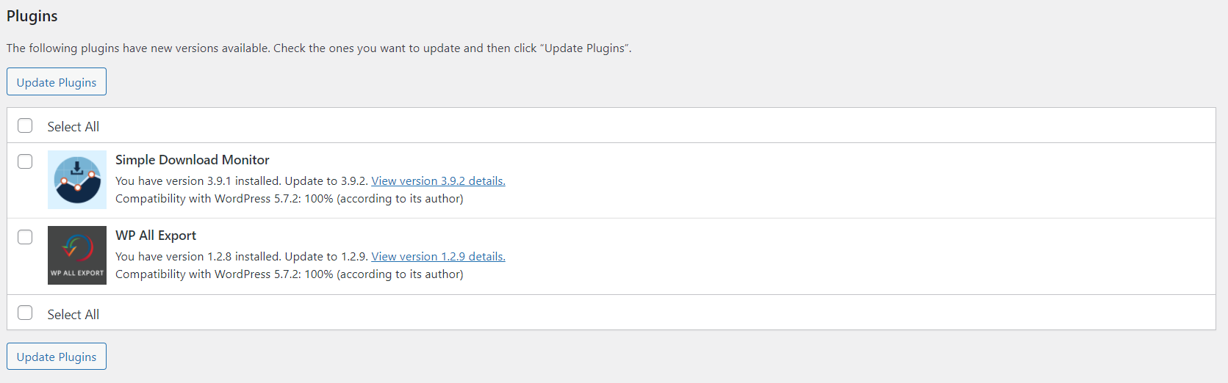
- Check “Select All” and then “Update Plugins”
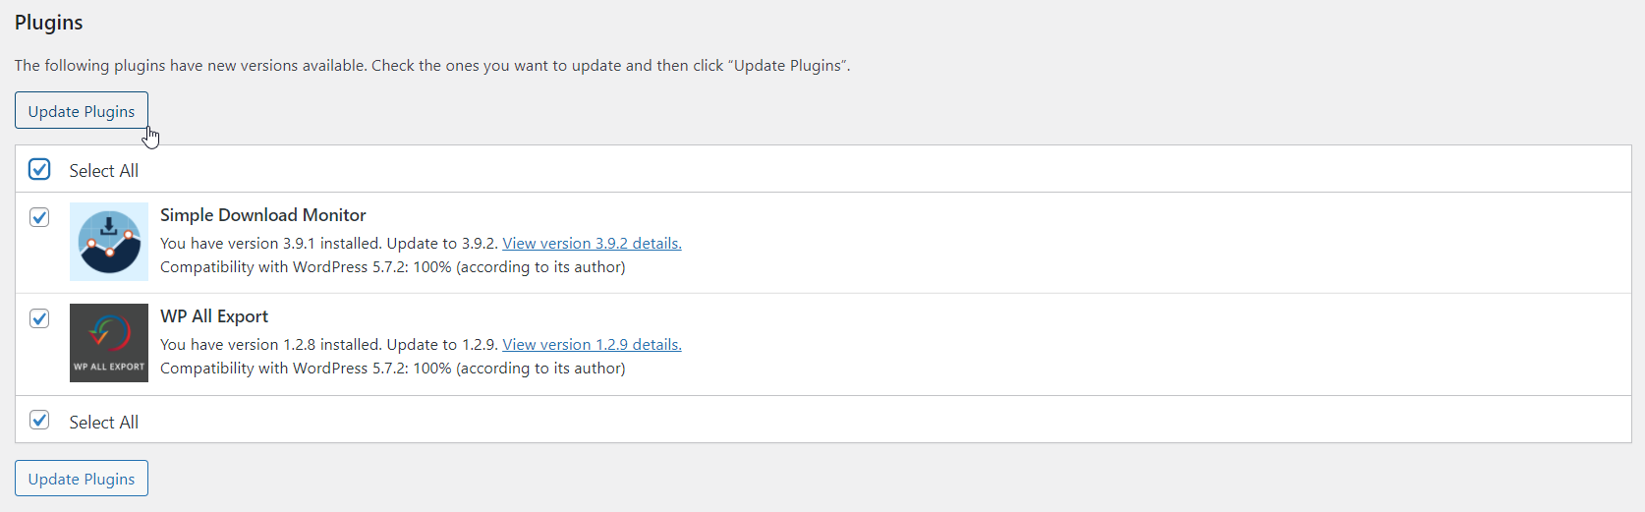
- Finally, verify all plugins have updated correctly
