How to Register a Lead in GoldMine
- Login to Remote
- Login to GoldMine
- From top ribbon, select “New Record”
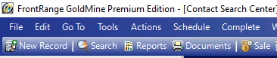
- With the New Record dialogue box now open, ready the information you will import. That information should include:
  - Company Name
  - Contact Name
    - First and Last
  - Email
  - Main Phone / Direct Phone
- Import the information into the relevant fields
- Change the Record Type in the top bar from Other to [Plain Contact Record]
- Change Record Type to LEAD
- Next, input the Account Manager
  - In most situations, the Account Manager should be provided by the person or persons requesting the lead be registered. If one is not provided and the Account Manager is not clear, then you will need to reach out to JA to verify who the assigned rep will be.
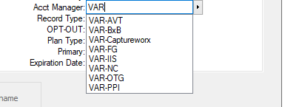
- Select OK
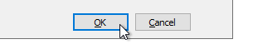
- Verify that the lead has been registered by using the GoldMine search bar to search for the lead

