Qualifying an International ead
    - Login to Dynamics CRM
    - Go to Marketing > Leads
    - Go to the lead record
    - Under the “Lead to Opportunity Sales…” bar click “Related”
    - 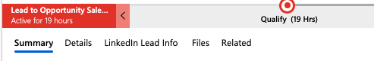
    - Under “Related: Common” click “Activities”
    - 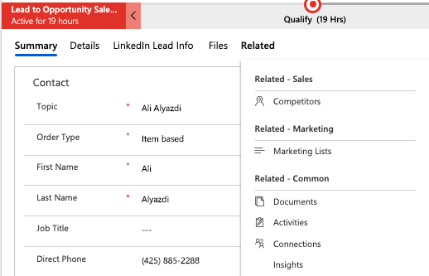
    - Click the arrow for the “New Activity” drop menu
    - 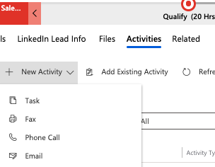
    - Select “Email”

    - From here, use the following information:
  - Subject Line: RE: [Original Intent Form] Request – [Contact Name]
  - Email Body:
Hello [First-Name],

I am hoping to gather just a little more information from you in order to better assist you. Just to clarify:

- Are you intending to use RightFax within the U.S. or internationally?

With an answer to this question, I should be able get you in touch with the appropriate group at Advantage.

Best,

[Signature]

    - When ready, click “Send” on the left side of the top bar.
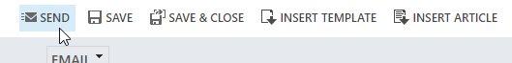
    - Update the record in CRM with all required information including the following:
      - Status: Contacted
      - Rating: Warm

