SOP – How to Update Leads in CRM
Process
- Login to Dynamics CRM
- From the dashboard, select Marketing
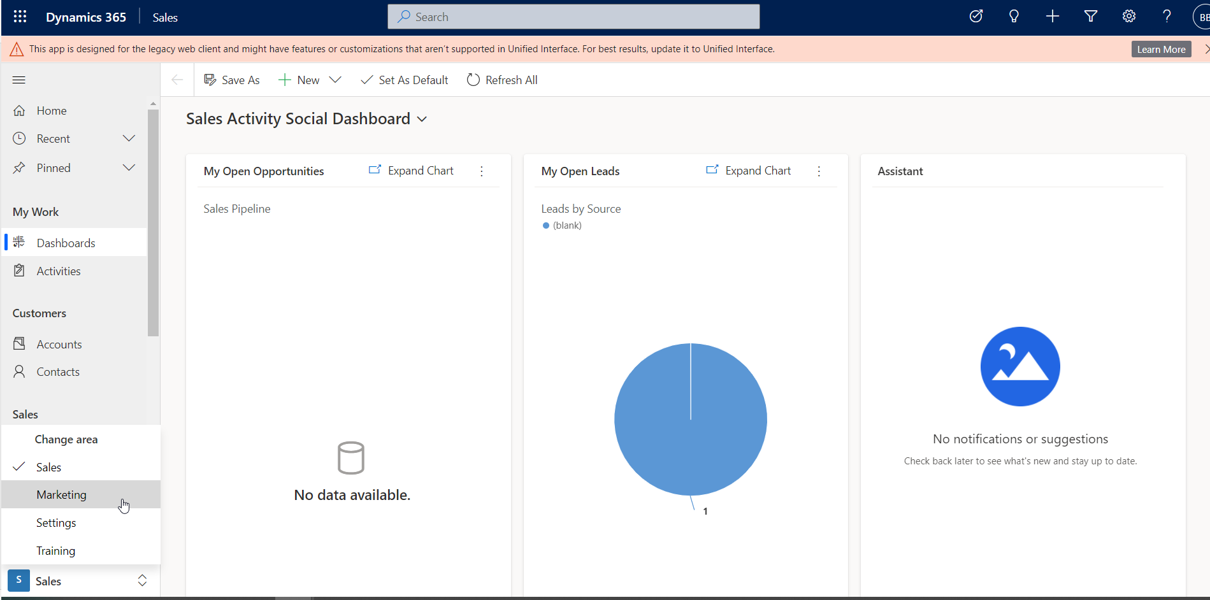
- Next, select Leads
- From here, click the name of the lead that needs to be updated
- Verify or edit / update to ensure the lead record has the following information:
  - Topic
    - First & Last Name
  - First Name
  - Last Name
  - Direct Phone
    - Some forms may put this number under Business Phone. You will need to copy and paste the number into the “Direct Phone” field.
  - Email
  - Last Form
  - Last Form Date
  - Accepted Terms Date
  - Newsletter Sign-up Date (if they subscribed to mailing list)
  - Company
  - Website
- In the top left-corner, update the lead tracking information
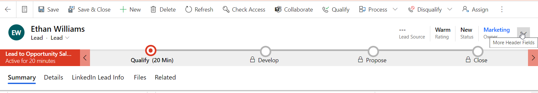
- The following information should be updated:
  - Lead Source
    - This can be found viewing the original form link below or the original email form submission
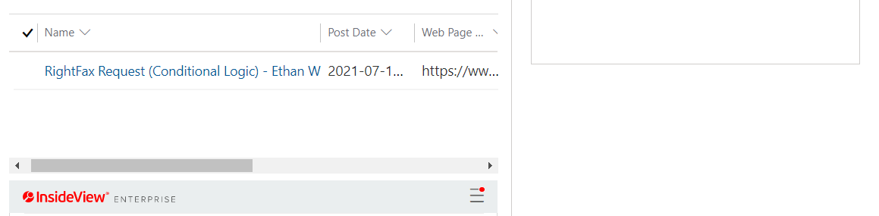
  - Rating
    - If disqualified, change to Cold
  - Status
  - Owner
    - Assigned Account Rep
- Save

