SOP – How to Check WordPress Site Security
Process
- Login to WordPress
- From the left-hand side bar, select WordFence
- From the WordFence dashboard, view Notifications
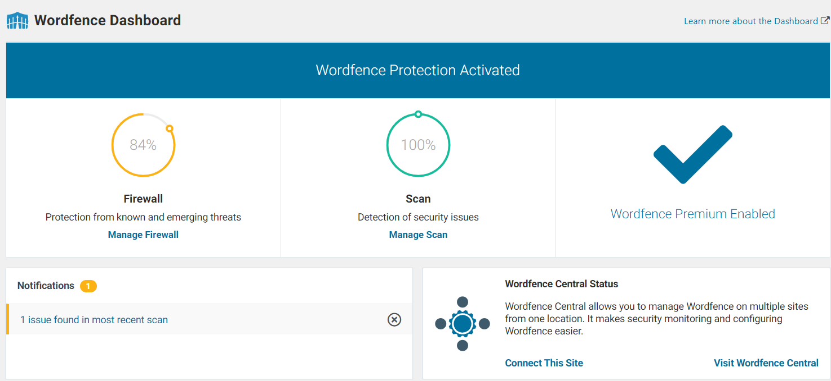
- If any issues were found in the most recent scan, select the available links.
- Review the issue results:
  - If a plugin has been abandoned or become a security risk (e.g. no longer compatible with WordPress), notify marketing@atechnologies.com and jandrews@atechnologies.com with the full status report of the issue. A new plugin will need to be found to address the issue.
  - If a theme has been abandoned or become a security risk (e.g. no longer compatible with WordPress), notify marketing@atechnologies.com and jandrews@atechnologies.com with the full status report of the issue. A new plugin will need to be found to address the issue.
  - If any security issue or risk is revealed, notify marketing@atechnologies.com and jandrews@atechnologies.com with the full status report of the issue. A new plugin will need to be found to address the issue.
- Finally, note any issues or errors on the EOW checklist.

