How to Better Search Replace ATNY & RC
- Login to the WordPress Site
- From the left-hand side bar, go to Tools > Better Search Replace
- In the Search for field, enter the following (one at a time):
  - ATNY
    - http://atechnologies.com/
    - http://new.atechnologies.com/
  - Resource Center
    - http://rightfax.atechnologies.com
- In the Replace with field, enter the following:
  - /
- Under Select Tables, select:
  - ATNY
    - wp_bc99a0bb660_postmeta
    - wp_bc99a0bb660_posts
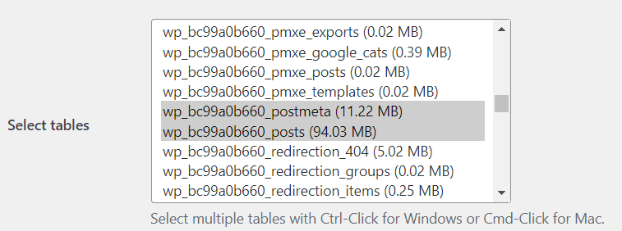
  - Resource Center
    - wp_02db4376fe_postmeta
    - wp_02db4376fe_posts
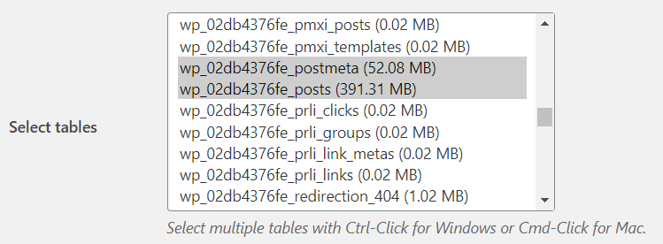
- By default, Run a dry run? will be checked. Double check that this checkbox is checked and then hit Run Search/Replace
- Once the plugin has finished, a new message box will appear showing the Dry Run results.
  - If 0 cells were found that need to be updated, then do not run the BSR.
  - If cells are found that need to be updated, then reconfigure the settings, uncheck Run a dry run?, and hit Run Search/Replace

