SOP – How to Backup WordPress Sites
Process
- Login to WordPress
- From the left-hand side bar, select Settings > UpdraftPlus Backups
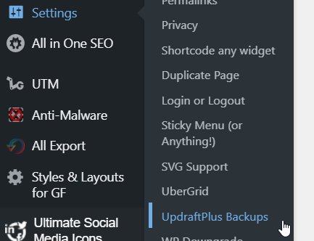
- From here, select Backup Now
- The Perform a Backup dialogue window will appear
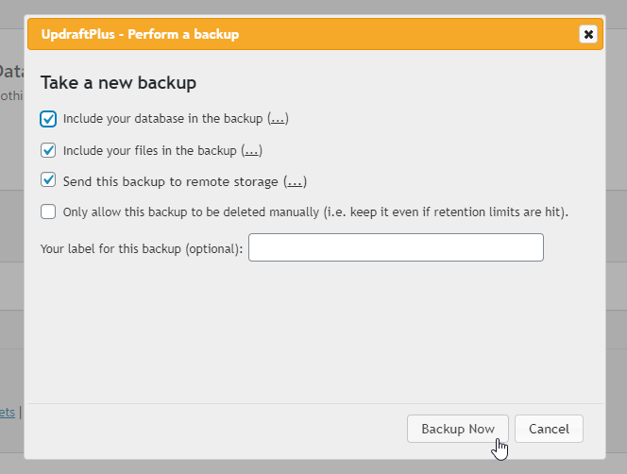
- From here, select Backup Now
- The backup should now begin. After the backup has completed, head to Cloudberry Microsoft Azure Blob Storage and verify that the backup is available in the specified folder
  - Please note that it may take up to 15 minutes for the backup files to appear via Cloudberry
