Checking Records in Goldmine
- View the lead form submission in Outlook
- Copy the email domain
- Login to Remote Desktop
- Open GoldMine
- Paste the email domain into the GoldMine Search Bar
  - Make sure search is set to “Email” and “Contains”
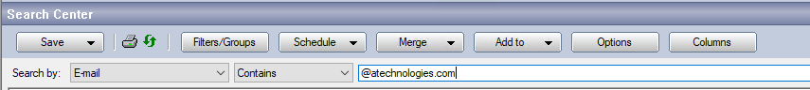
- Verify if any records exist for this domain
- If no records exist, verify the current company name, paying special attention to spelling and capitalization
- Next, search for the Company name in Goldmine
  - Make sure search is set to “Company” and “Contains”
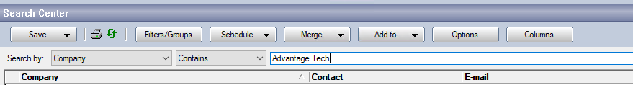
  - Depending on the company name, you may need to try searching for different variations.
    - E.g.: California Healthcare Services > California Healthcare > CA Healthcare Services or Red River Community Hospital > Red River Hospital
  - If you do see a company appear, please be sure to pay special attention to the website domain. If you are unsure if they organizations are related, view the organization domain in a search engine of your choosing and see if they match.

Checking Records in ASP

- Login to ASP via Remote Desktop
- Select Client Management Tool
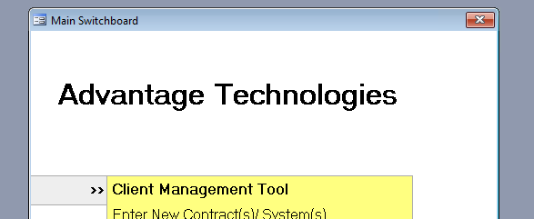
- Search for the Company Name in the top Search Bar
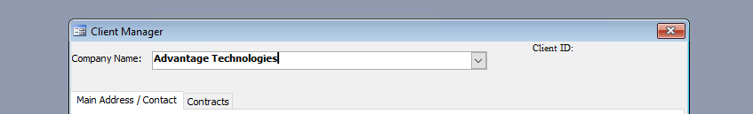
- Depending on the company name, you may need to try searching for different variations.
    - E.g.: California Healthcare Services > California Healthcare > CA Healthcare Services or Red River Community Hospital > Red River Hospital
- If nothing appears, select “Search” on the bottom bar
- From here, search for the company name with an asterisk “*” in front of the company name.
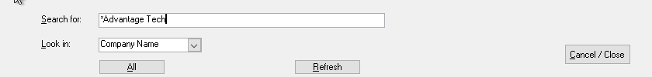
- If no results appear, then no records exist in ASP.

