SOP - Referring a Lead to OT
The lead referral process has been updated as of February 2021:
- Open the OpenText Partner Referral Form (https://www.opentext.com/products-and-solutions/partners-and-alliances/partner-referral)
  - Fill out the Partner Information section:
    - Company Name: Advantage Technologies
    - Contac Name: Jonathan Andrews
    - Contact Email: referrals@atechnologies.com
    - Contact Phone: 866-730-1700
    - Partner City: New York
    - Partner Country: United States

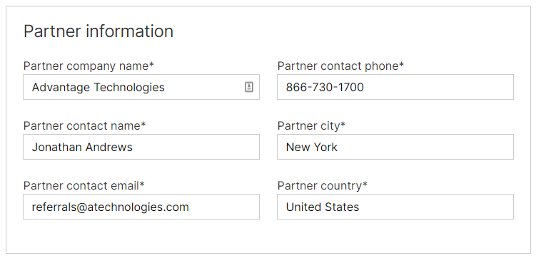
  - Fill out Prospect Information
  - Fill out Opportunity Information
    - Product Focus: BN – F&DD – RightFax
    - Deal Size: Undisclosed
    - Close Date: 3 months from current date (End of Month)
    - Solution Pillar: Business Network
    - Opportunity Summary: Relevant Lead Information
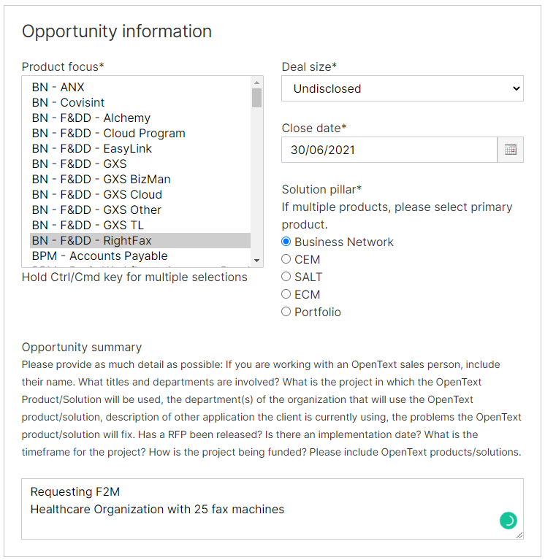
  - Before submitting page, take screen shots of each section, including:
    - Partner Information
    - Prospect Information
    - Opportunity Information
    - Terms & Conditions
      - With Acknowledgement & Terms / Conditions checked
  - After submitting page, take a screenshot of the confirmation page.
  - Save these screenshots in a new folder under ATI Sales > General > Sales Processes > Cloud Deal Tracking > New Folder
    - The New Folder Naming Structure should be:
      - YYYYMMDD_ACCOUNTREP_REQUESTTYPE_COMPANYNAME
        - E.g.: 20210304_House_F2M_Advantage
        - E.g.: 20210304_SK_RFC_Terra_Universal
        - E.g.: 20210304_House_International_HausBaus
- Next, you will need to send an email. Please follow the following instructions:
    - Subject Line: REFERRAL: [Referral Type] – [Organization Name]
      - E.g. REFERRAL: F2M – Smithtown Hospital
      - E.g. REFERRAL: RFC – Jane Doe Insurance
    - TO: bryttanj@opentext.com
    - CC: referrals@atechnologies.com, dciccone@opentext.com, and fcalabre@opentext.com
    - Email Body:
Hello,

We just registered the following lead through the Partner Referral form on the OpenText website:

Prospect Information
Company Name

Contact Name
Contact Email
Contact Phone

Regards,
[Signature]
    - ATTACHMENTS: All Screenshots from OT Partner Referral
- Send Email
- Next, head to ATI Sales > General > Sales Processes > OT Cloud Deal Referrals
- Create a new record for the new lead:
- When OT returns with the Assigned Rep information, update the record to include the Assigned Sales Rep.
  - If more than 48 hours have passed without receiving rep information, send an email to Bryttani (bryttanj@opentext.com) to confirm rep assignment.

