SOP - Disqualifying a Lead
- If the lead is disqualified, you will need to customize the general disqualification message to fit the specific reasons for this lead. Below, find an example of this email:
Hello [first-name],

Thank you for your recent submission. I am hoping to gather just a little more information from you regarding your needs as well as provide more information about RightFax to ensure it is the perfect fit for you.

As an enterprise-level software, RightFax is best suited for organizations that see a high transmission of faxes or a minimum of 500 of fax pages per day. Starting at about $8,000, RightFax provides flexible integrations to seamlessly incorporate fax into all existing document delivery workflows.

I see that you are a bit below the typical fax volume threshold for RightFax. Just to clarify:

Would you still like to move forward with receiving a RightFax [quote / demo / upgrade]?

If so, please respond to this email and I should be able get you in touch with the appropriate group at Advantage.

Best,

Name
Job Title
Email
- Login to Dynamics CRM
- Go to Marketing > Leads
- Go to the lead record
- Under the “Lead to Opportunity Sales…” bar click “Related”
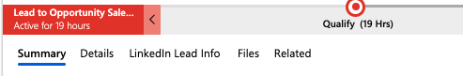
- Under “Related: Common” click “Activities”
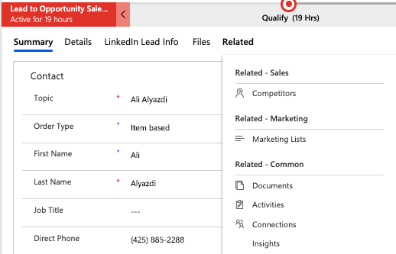
- Click the arrow for the “New Activity” drop menu
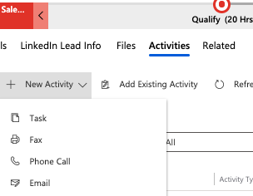
- Select “Email”

- From here, paste the disqualification email and update the Subject line to say:
  - Subject Line: RE: RightFax [Form Name] Request – First Name & Last Name
    - Example: RE: RightFax Demo Request – John Doe
    - When ready, click “Send” on the left side of the top bar.
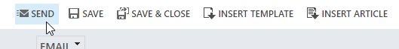
    - Update the record in CRM with all required information including the following:
      - Status: Contacted
      - Rating: Cold

